C Programming: DFA, CFG and NFA Programs
Questions with code and sample output screenshots

Program 1
Question: 1. Write a C program to simulate a Deterministic Finite Automata (DFA) for strings that start with a and end with a.
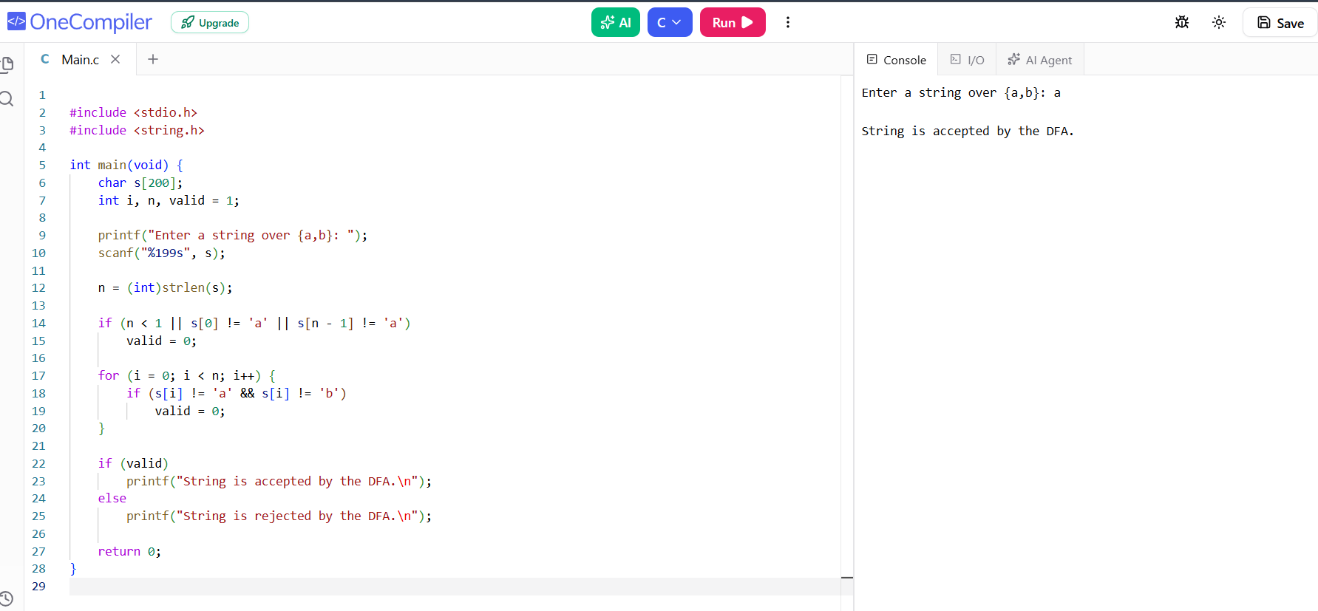
Sample output shown in the screenshot.

Program 2
Question: 2. Write a C program to simulate a Deterministic Finite Automata (DFA) for strings that start with 0 and end with 1.
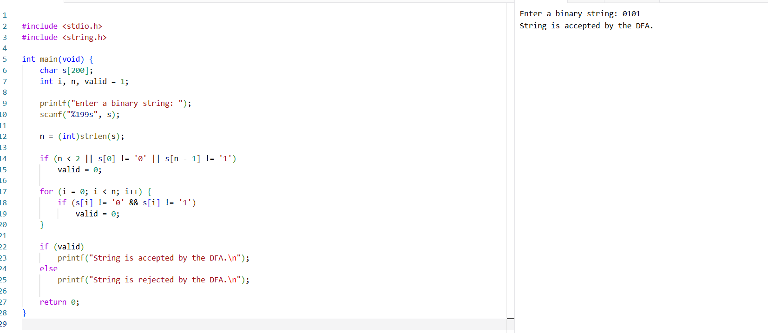
Sample output shown in the screenshot.

Program 3
Question: 3. Write a C program to check whether a given string belongs to the CFG: S → 0A1, A → 0A | 1A | ε.
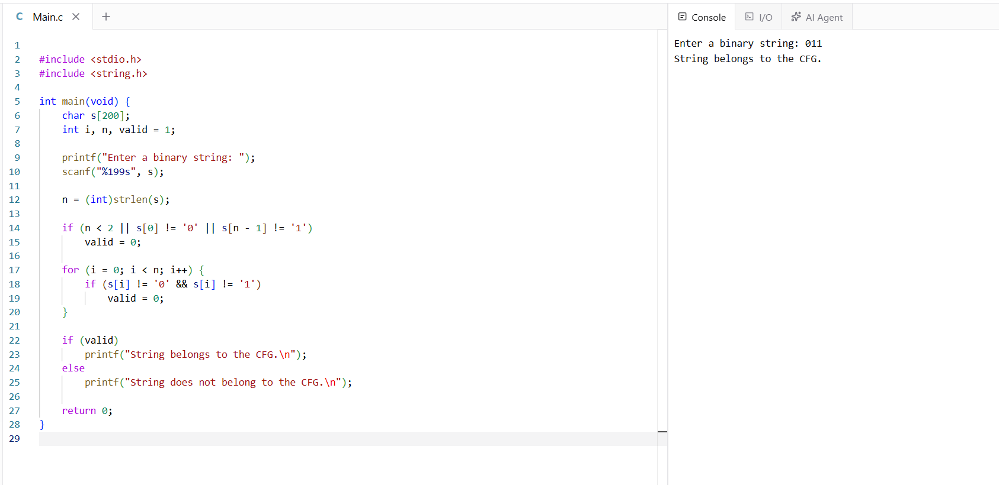
Sample output shown in the screenshot.

Program 4
Question: 4. Write a C program to check whether a given string belongs to the CFG: S → 0S0 | 1S1 | 0 | 1 | ε.
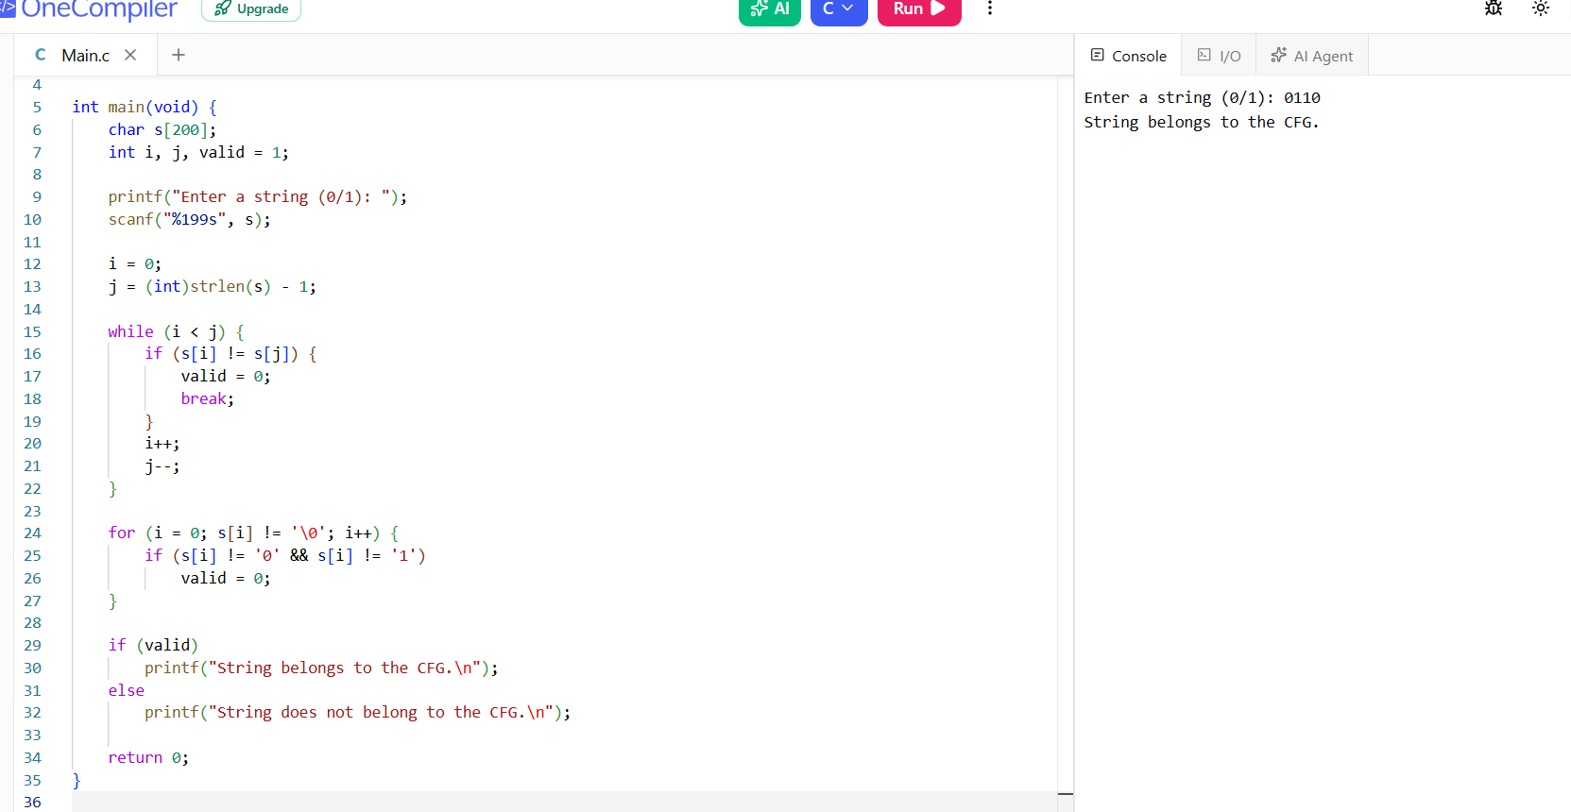
Sample output shown in the screenshot.

Program 5
Question: 5. Write a C program to check whether a given string belongs to the CFG: S → 0S0 | A, A → 1A | ε.
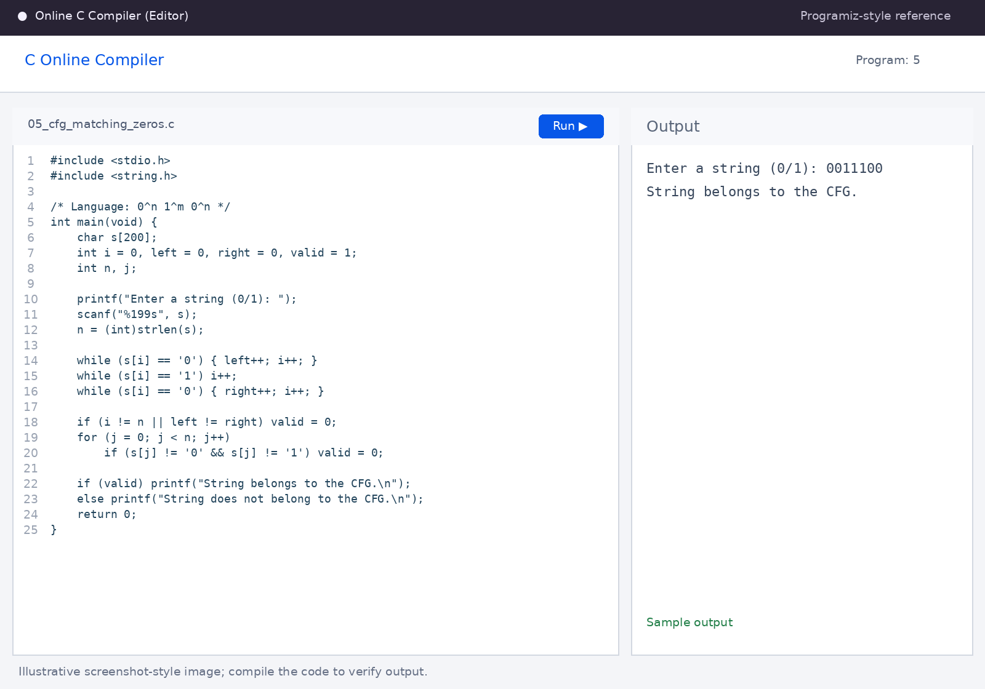
Sample output shown in the screenshot.

shown in the screenshot.

